Smart Healthcare Data Analysis
& Disease Risk Prediction
Cardiovascular Risk Analytics Report
Gexton Education — Summer Internship Program
Prepared for: Sir Muhammad Arham MH
Patient records analyzed: 70,000 → 68,593 after data cleaning

Executive Summary
This report analyzes 70,000 anonymized patient health records to identify the strongest drivers of cardiovascular disease and to build a model that estimates each patient's individual disease risk probability. Roughly half of the patients in this dataset have diagnosed cardiovascular disease, making it well suited for risk modeling.
Four things stood out:
- Blood pressure dominates. Blood pressure (systolic and diastolic) is by far the strongest predictor of disease — more influential than age, cholesterol, weight, or lifestyle habits combined.
- Age compounds risk. Disease risk roughly triples between the youngest and oldest patient groups in this dataset (23% at age 30-40 vs. 67% at age 61-65).
- Cholesterol & glucose matter, but less. Elevated cholesterol and glucose meaningfully raise risk, but their effect is smaller than blood pressure's.
- Lifestyle factors were the weakest signal. Smoking, alcohol use, and physical inactivity showed only small effects in this dataset — smaller than typically expected — likely because self-reported lifestyle data is noisy and confounded with other factors.
A Random Forest classifier trained on patient health indicators correctly predicts disease status 73.4% of the time and achieves a ROC-AUC of 0.80 — a solid, clinically useful starting point for a triage tool, generating a personalized risk probability for every patient.

Data Source & Methodology

Data Source
The analysis uses the publicly available Cardiovascular Disease dataset published on Kaggle by contributor Svetlana Ulianova, containing 70,000 anonymized patient records collected at the time of a medical examination.
Attribute | Detail
Source | Kaggle (kaggle.com/datasets/sulianova/cardiovascular-disease-dataset)
Records | 70,000 patients
Fields | 12 — demographics, exam results, lifestyle factors, and disease outcome
Target variable | cardio (presence of cardiovascular disease: 0 = No, 1 = Yes)

Tools & Technologies
The full pipeline — data cleaning, exploratory analysis, feature engineering, and predictive modeling — was built end-to-end in Python.
Tool / Library | Purpose
Python 3 | Core programming language for the entire pipeline
Pandas & NumPy | Data loading, cleaning, transformation, and feature engineering
Matplotlib & Seaborn | Statistical charts and visualizations
Scikit-learn | Logistic Regression & Random Forest models, scaling, train/test split, evaluation metrics
Visual Studio Code | Development environment for writing and running the analysis scripts

1. Data Understanding & Cleaning

1.1 Dataset Overview
The raw dataset contains 70,000 patient records across 12 original columns covering demographics (age in days, gender, height, weight), medical indicators (systolic/diastolic blood pressure, cholesterol, glucose), lifestyle factors (smoking, alcohol, physical activity), and the target variable (cardio: presence of cardiovascular disease).
Check | Result
Total records | 70,000
Missing values | 0 (no nulls in any column)
Fully duplicated rows | 0
Duplicate rows (ignoring patient ID) | 24
Columns | 13 (id, age, gender, height, weight, ap_hi, ap_lo, cholesterol, gluc, smoke, alco, active, cardio)

1.2 Missing Values & Data Quality Issues
No nulls were present, but the dataset had a well-documented data-entry quality issue: blood pressure fields contained physically impossible values (including negative numbers and readings in the thousands), and a small number of height/weight entries were biologically implausible (e.g., 50kg appearing alongside heights under 100cm).

1.3 Cleaning Strategy
- Duplicates: Removed 24 duplicate patient records (ignoring the ID column, which is just a sequential identifier).
- Age: Converted age from days into a readable age_years column (range: 29.6 - 64.9 years — clinically sensible, confirming the raw age field itself was reliable).
- Height: Removed 53 records with height outside a plausible 120-220cm adult range.
- Weight: Removed 7 records with weight outside a plausible 30-200kg adult range.
- Blood pressure: Removed 1,222 records with systolic readings outside 70-250 mmHg or diastolic outside 40-200 mmHg — these were almost certainly data-entry errors (e.g., decimal points dropped, producing values like 1,200 or -150).
- Logical consistency: Removed 101 records where diastolic exceeded systolic, which is physiologically impossible.
In total, 1,407 records (2.0%) were removed, leaving 68,593 clean records — a small, justified trade-off that protects every downstream statistic and model from being distorted by data-entry errors.

1.4 Initial Data Insights
- The dataset is well-balanced: 49.5% of patients have cardiovascular disease, 50.5% do not — ideal for training a classifier without needing to correct for class imbalance.
- All categorical fields (gender, cholesterol, glucose, smoke, alcohol, active) contained only their documented valid values, with no stray codes.
- Patient ages span 30-65 years — a middle-to-older-age adult population, which is the typical population of interest for cardiovascular screening.

2. Exploratory Data Analysis

2.1 Risk Distribution
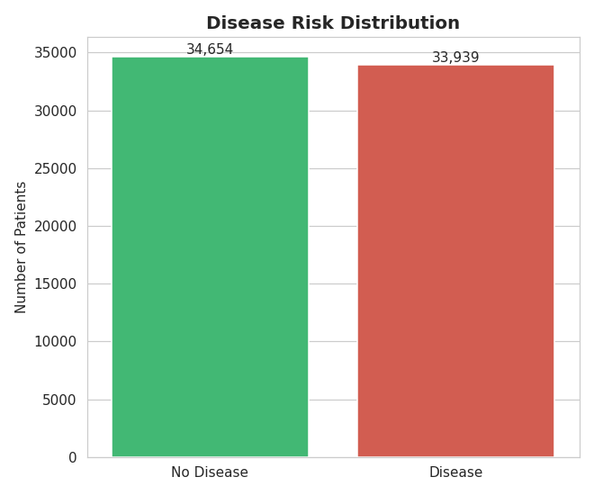
Figure 1. The dataset is almost perfectly split between healthy and diseased patients.

2.2 Age vs. Disease Risk
Risk climbs steadily and substantially with age:
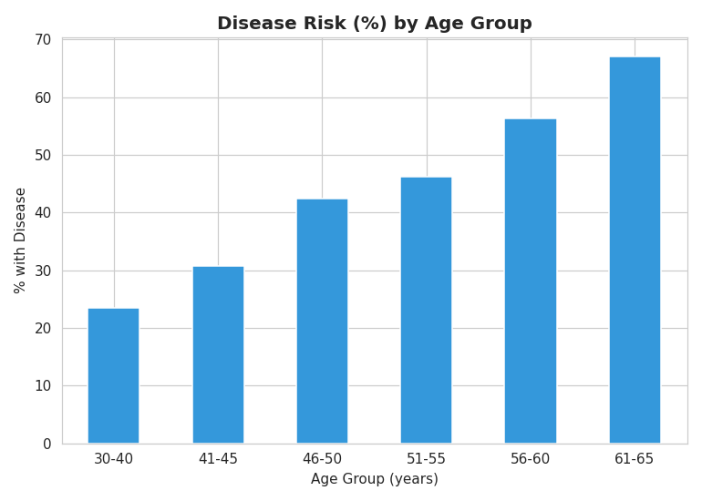
Figure 2. Disease prevalence by age group — nearly a 3x increase from the youngest to oldest cohort.

2.3 Blood Pressure Analysis
Patients with disease show markedly higher blood pressure on both measures — average systolic 134 mmHg vs. 120 mmHg in healthy patients, and diastolic 85 vs. 78 mmHg. The spread (box width) is also wider among diseased patients, indicating more variable and often poorly controlled blood pressure.
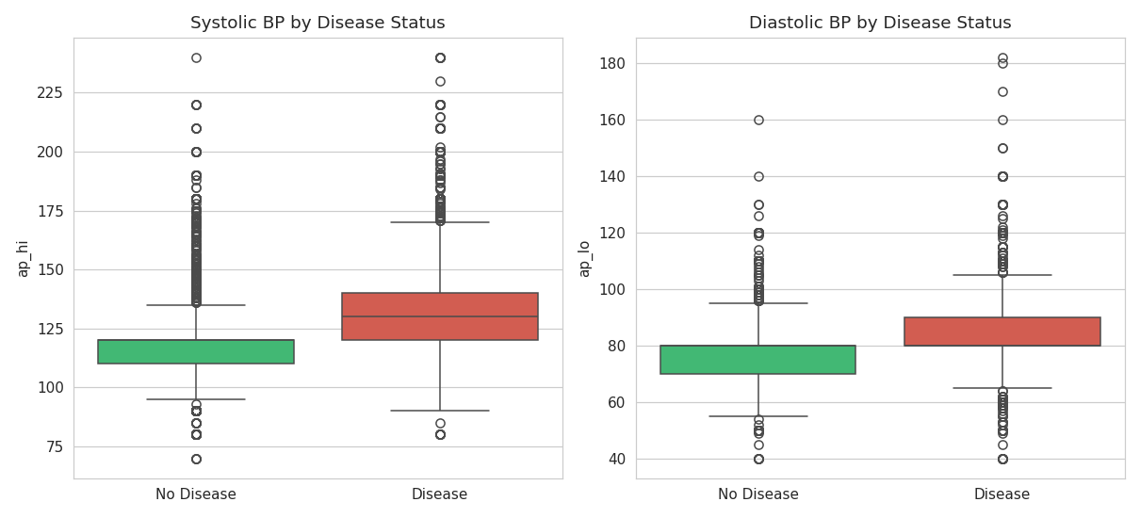
Figure 3. Systolic and diastolic blood pressure by disease status.

2.4 Cholesterol & Glucose Impact
Cholesterol shows a strong, consistent relationship with disease risk, roughly doubling from normal to well-above-normal levels. Glucose shows a similar but more modest pattern.
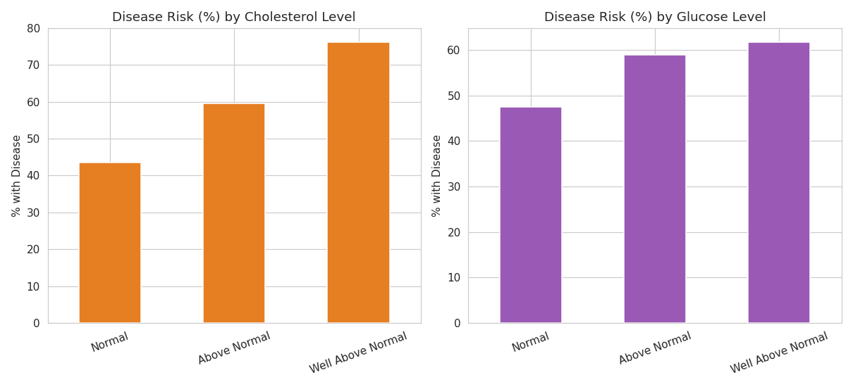
Figure 4. Disease risk (%) by cholesterol level (left) and glucose level (right).

2.5 Lifestyle Factors
Smoking, alcohol consumption, and physical activity showed comparatively small effects on disease risk in this dataset. Smokers actually showed a marginally lower disease rate than non-smokers (46.8% vs. 49.7%) — a counterintuitive finding most likely explained by smokers in this sample skewing younger, and by the well-known limitations of self-reported lifestyle survey data, rather than smoking being protective. Physical activity showed the expected modest protective effect (48.5% vs. 53.3% disease rate).
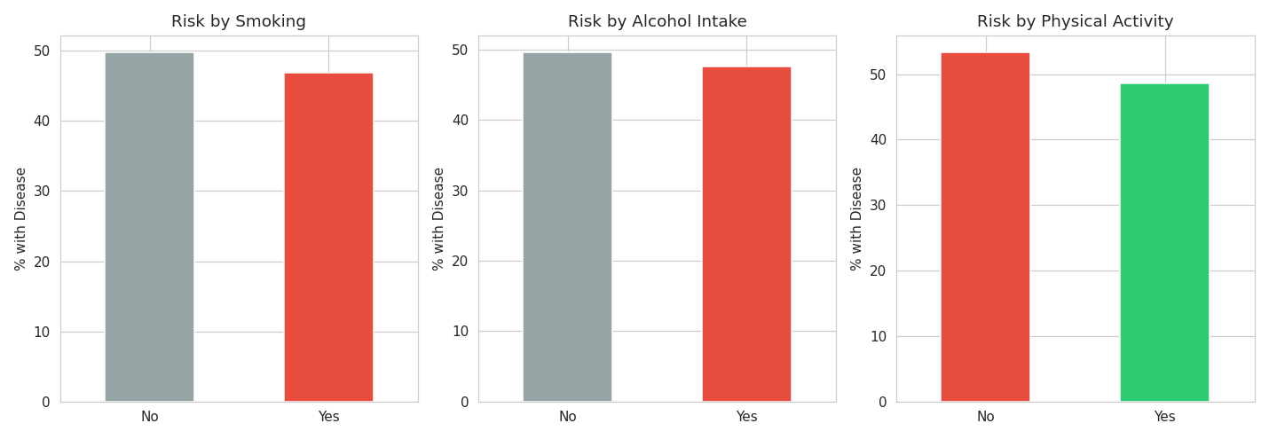
Figure 5. Disease risk by smoking, alcohol intake, and physical activity.

2.6 Correlation Heatmap
The correlation heatmap confirms the patterns above quantitatively. The five strongest correlates of disease are: systolic BP (0.43), diastolic BP (0.34), age (0.24), cholesterol (0.22), and weight (0.18). Lifestyle variables (smoking, alcohol, activity) all correlate weakly with the outcome (under 0.05 in magnitude).
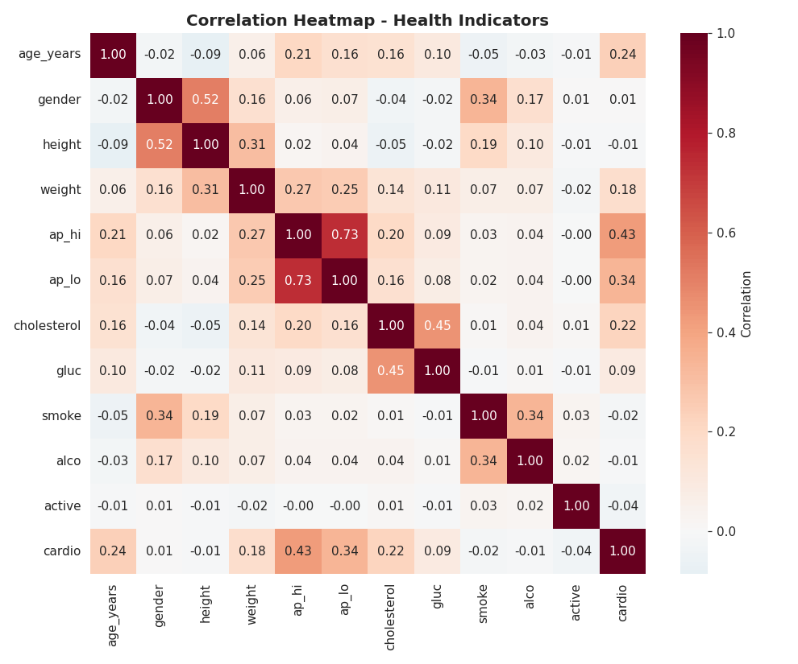
Figure 6. Correlation heatmap across all health indicators and the disease outcome.

3. Feature Engineering & Risk Analysis

3.1 New Features Created
- BMI: Body Mass Index, calculated as weight(kg) / height(m)^2, with WHO-standard categories: Underweight, Normal, Overweight, Obese.
- Blood Pressure Category: Standard clinical blood-pressure staging: Normal, Elevated, Hypertension Stage 1, Hypertension Stage 2.
- Risk Score: A 0-10 rule-based score combining age, BP stage, cholesterol, glucose, BMI, and lifestyle habits — designed as a quick, explainable triage score independent of the machine learning model.
- Risk Group: Patients grouped into Low / Medium / High based on risk_score thresholds.

3.2 Validating the Engineered Features
The engineered risk_score and supporting categories were checked against actual outcomes, and the separation was strong and monotonic:
Risk Group (rule-based score) | Actual Disease Rate
Low | 18.8%
Medium | 45.1%
High | 73.3%

This simple, explainable score (correlation with outcome: 0.40) already outperforms any single raw feature, making it useful on its own as a non-technical screening tool for clinicians who want a quick read without running a model.
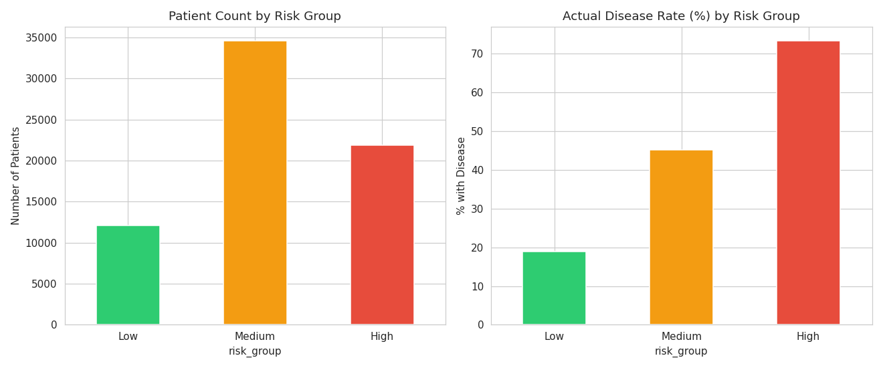
Figure 7. Patient counts and actual disease rates across Low/Medium/High risk groups.
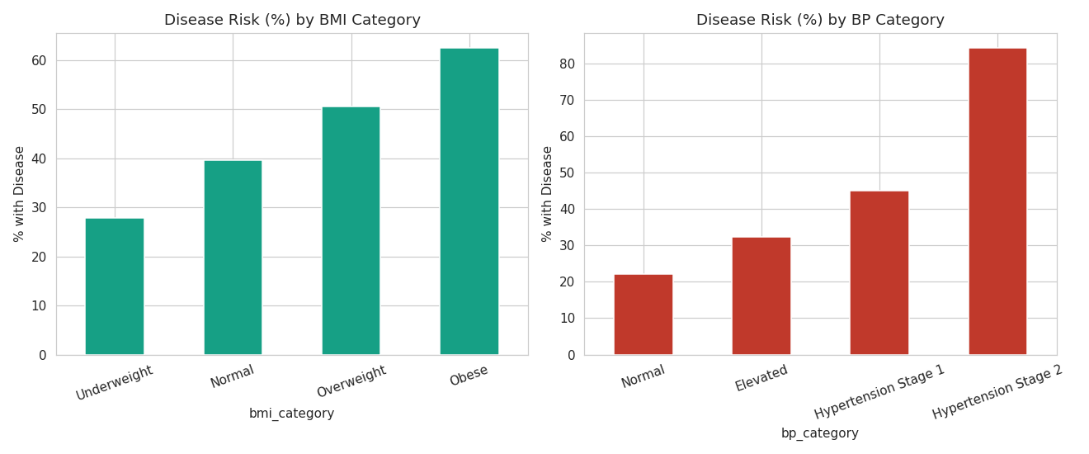
Figure 8. Disease risk by BMI category (left) and blood pressure category (right) — both show a clear, clinically expected gradient.

3.3 Business / Healthcare Interpretation
- Patients in Hypertension Stage 2 and the Obese BMI category should be flagged as priority candidates for proactive screening — both show disease rates well above the dataset average.
- The High-risk group (top tier of the rule-based score) represents roughly a third of the patient population but accounts for a disproportionate share of actual disease cases — a natural target for a focused early-intervention program.
- Because the rule-based score uses only easily collected vitals (age, BP, cholesterol, glucose, BMI, lifestyle), it can be computed at any routine checkup without lab work beyond a standard panel.

4. Predictive Modeling & Insights

4.1 Model Setup
Two classification models were trained on a 80/20 train-test split (54,874 training / 13,719 test records, stratified to preserve the disease/no-disease balance): Logistic Regression (a simple, interpretable baseline) and Random Forest (a more flexible ensemble model). Both used age, gender, height, weight, BMI, blood pressure, cholesterol, glucose, smoking, alcohol, and activity as input features.

4.2 Model Performance
Model | Accuracy | Precision | Recall | F1 Score | ROC-AUC
Logistic Regression | 72.9% | 75.4% | 67.4% | 0.711 | 0.793
Random Forest | 73.4% | 75.5% | 68.5% | 0.718 | 0.801

Random Forest was selected as the final model — it edges out Logistic Regression on every metric, and its ROC-AUC of 0.80 indicates good discrimination between diseased and healthy patients (0.5 = random guessing, 1.0 = perfect). For context, this level of accuracy is in line with published results on this dataset, which is known to have an inherent ceiling around 73-74% accuracy given the available features (a fuller clinical picture — e.g. family history, diet, ECG results — would likely push this higher).
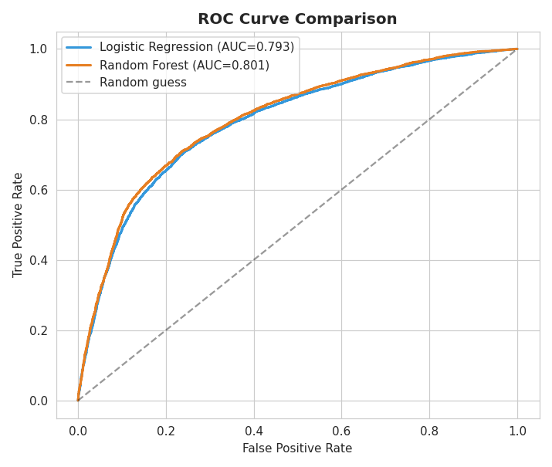
Figure 9. ROC curve comparison — Random Forest (AUC 0.801) slightly outperforms Logistic Regression (AUC 0.793).
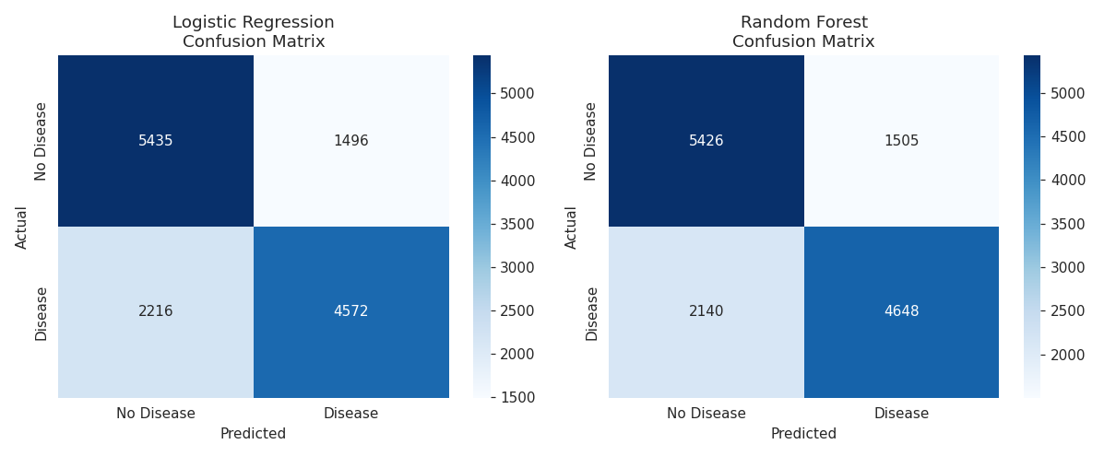
Figure 10. Confusion matrices on the held-out test set (13,719 patients).

4.3 Feature Importance
The Random Forest model confirms what the EDA suggested: systolic blood pressure alone accounts for nearly half of the model's predictive power, with diastolic BP and age rounding out the top three. Lifestyle features (smoking, alcohol, activity) contributed the least.
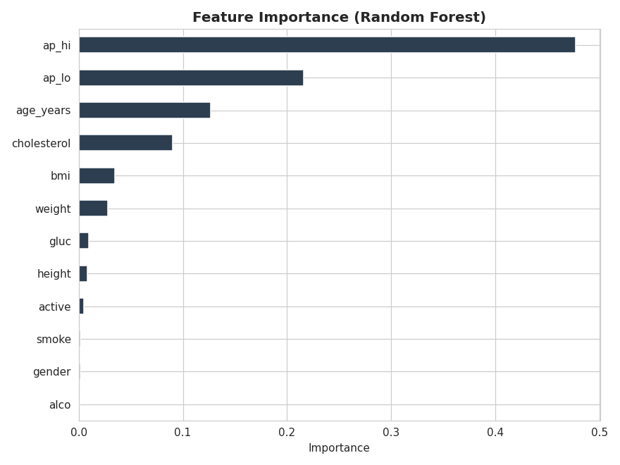
Figure 11. Feature importance ranking from the Random Forest model.

4.4 Risk Probability Predictions
As requested, the final model generates an individualized disease risk probability for every patient in the dataset (not just the test set), using predict_proba() — a 0-100% score reflecting the model's confidence that a given patient has cardiovascular disease. These probabilities are banded into Low (<30%), Medium (30-60%), and High (60%+) for easy triage.
Predicted Risk Band | Patient Count | Share of Patients
Low (<30%) | 20,049 | 29.2%
Medium (30-60%) | 23,796 | 34.7%
High (60%+) | 24,748 | 36.1%

Full per-patient results (ID, key health indicators, rule-based risk score, model risk probability, and predicted risk band) are provided in the accompanying file cardio_risk_predictions.csv.

4.5 Preventive Care Recommendations
- 1. Prioritize blood pressure screening and management above all other interventions — it is the single strongest lever for risk reduction in this population.
- 2. Route patients flagged High risk (probability ≥60%) into a focused early-intervention pathway: cardiology referral, lipid panel, and a structured blood-pressure management plan.
- 3. For Medium-risk patients, increase checkup frequency and monitor cholesterol/glucose trends — many in this band are one or two risk factors away from the High band.
- 4. Use the simple rule-based risk_score as a low-friction front-line triage tool at routine visits, reserving the full model for cases needing a more precise probability estimate.
- 5. Treat the weak lifestyle signal with caution rather than as evidence lifestyle doesn't matter — it most likely reflects limitations of self-reported survey data, not a true absence of effect; lifestyle counseling remains good general practice.

Appendix — Deliverables & File Guide
- cardio_train_raw.csv — original unmodified dataset
- cardio_train_cleaned.csv — cleaned dataset (68,593 rows)
- cardio_train_features.csv — cleaned dataset plus engineered features (BMI, risk score, risk group, etc.)
- cardio_risk_predictions.csv — per-patient model risk probabilities and predicted risk bands
- 01_data_cleaning.py, 02_eda.py, 03_feature_engineering.py, 04_modeling.py — analysis scripts
- 12 chart PNGs covering distributions, relationships, segmentation, and model evaluation
- README.md / README.txt — project summary and file guide

